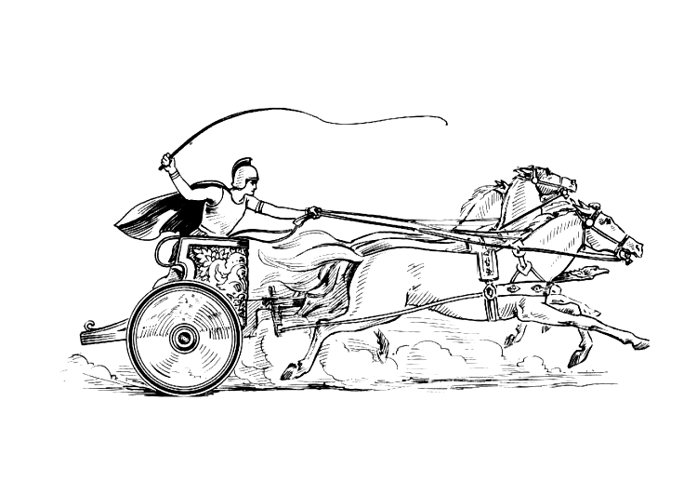Manduessedum - Mancetter Village (Place of War Chariots)
Mancetter Parish Council
Serving the People of Mancetter and Ridge Lane

You are invited to the Annual Parish Council Meeting
to be held in the Schoolroom of St Peter’s Church Mancetter
on Tuesday 24th May 2022 at 7pm prompt.

A specialist portable air filtration system will be plugged in throughout the meeting;
to provide COVID ventilation, allowing the doors to be closed.

AGENDA

- Appointment of Chair and Vice Chair – signing of Declaration of Acceptance of Office.

- Co-option to one of two Parish Councillor vacancies as authorised by NWBC Democratic Services. Signing of Declaration of Acceptance of Office, Code of Conduct and Pecuniary Interests.

- Welcome and Apologies.

- Chairman’s request that anyone recording the meeting to make themselves known.

- Notice of Interest.

- Public Question time up to 15 Minutes for Members of the Public to raise issues.

- Minutes of the last meeting:

- To accept the draft minutes of the Parish Council Meeting held on 22nd March 2022.

- To review the draft minutes of the Annual Parish Meeting held on 26th April 2022 to be formally approved at the next Annual Parish Meeting on 25th April 2023.

- Matters Arising from the Parish Council Meeting on 22nd March 2022 - not covered in any other agenda points.

- To receive the list of Meeting Dates for the new Parish Council year.
- Update on Ridge Lane Chapel and Community Room.
- Update on Community Speed Watch training and locations and signage.

- Report from the Police.

- Report from County and Borough Councillors.

- Finance

- Formal receipt of the accounts for 2021/22.
- Formal signing of section one of the Annual Governance and Accountability Return for the year 2021/22 – Annual Governance Statement.
- Formal signing of section two of the Annual Governance and Accountability Return for the year 2021/22 – Accounting Statements.
- Signing of all payments since the last meeting in accordance with the Bank mandate.
- Update on Parish Council debit card, payment limits and Account closure.
- Approval of payment to Guides for Annual Parish meeting refreshments.
- Renewal of WALC Membership at a cost of £623.00 for 2022/2023.
- To discuss any Grant Applications received.
- Update on Platinum Jubilee Expenditure.

- Report on final arrangements for Mancetter Parish Platinum Jubilee celebrations.

- Location of shield display and 70-year trail.
- Decoration of Community Spaces.
- Councillor involvement.

- Review of Statutory Documents, Responsibilities and Membership of External Groups.

- Standing Orders – Revised Version as of April 2022.
- Pecuniary Interests – Advise of any changes and update forms for NWBC Monitoring Officer.
- Code of Conduct – Update on adoption of 2020 amendments by NWBC.
- To agree membership of Committees and External Groups for the new council year.
- Feedback from Training and Meetings attended.
- To set up a Working Group to review the policies and procedures listed below to bring before Full Council for approval:

- Complaints Procedure
- Freedom of Information Policy
- Grant Making Policy
- Risk Assessment – Financial Regulations
- Risk Assessment – Allotments
- Risk Assessment – Cemetery / Handyman
- Media Policy
- Grievance Procedure
- Training Policy
- Asset Register
- Allocation of Reserves
- Insurance Details
- Environmental Policy

- Planning Matters and New Applications since the previous meeting:

- Update on Enforcement issues.
- Update on Approved and Pending Applications
- To discuss any new applications received.

- Cemetery and Maintenance around the Parish

- To approve the costings and requirements for new Cemetery Ledgers.
- To discuss the creation of an area to scatter ashes around the newly planted trees in “Jubilee Avenue” and appropriate signage suitable for the conservation area.
- To discuss an amendment to the policy for setting Cemetery Fees to recognise official public service within the parish for out of parish residents.

- Date of next meeting-

Tuesday 26th July 2022

7pm at St Peter’s Church Mancetter.

Signed

Date 18th May 2022.

Elane Higgins
Parish Clerk Mancetter Memorial Hall Old Farm Road Mancetter CV9 1QN Tel: 01827 722552 Email: parishclerk@mancetter.org.uk
Website: www.mancetter.org.uk

Manduessedum - Mancetter Village
(Place of War Chariots)
Mancetter Parish Council
Serving the People of Mancetter and Ridge Lane.

